Connor Perron

BCS426

Prof. Aydin

Spring 2021

**Question 1: Create a C# class called Document**

* 1. **with the following Properties:** 
     1. **Name (string)**
     2. **NumberOfPages (int)**
     3. **CreatedOn (DateTime): make this a readonly property. Note that** [**DateTime**](https://docs.microsoft.com/en-us/dotnet/api/system.datetime?view=netcore-3.1) **is a struct in the namespace System**
  2. **Add a constructor to allow initialization of all the properties ~~setting properties Name and NumberOfPages front~~**
  3. **Add ToString Method (hint: override toString method of** [**System.Object**](https://docs.microsoft.com/en-us/dotnet/api/system.object?view=netcore-3.1) **class)**

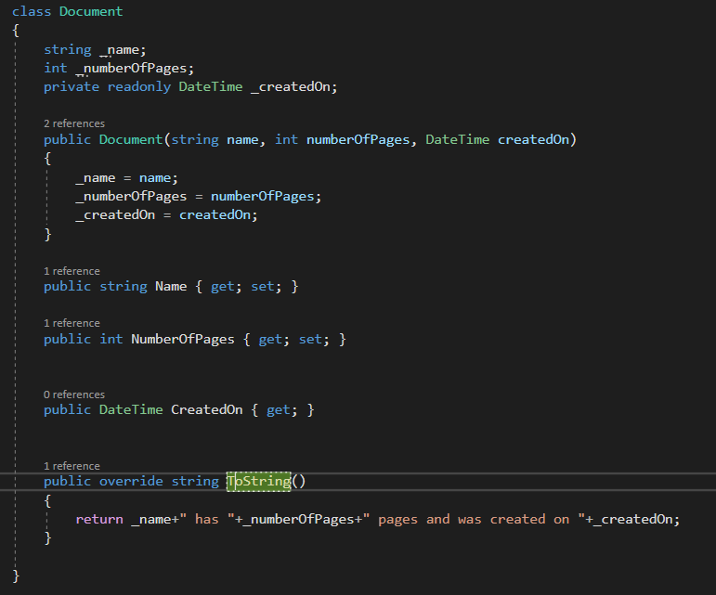

**Then, write a Main method to test your class Document.**

1. **Create document1 with name “PhoneNumbers.txt” and 3 pages**
2. **Create document2 with name “Report.docx” and 30 pages**
3. **Demo how you cannot change the CreatedOn property of each document object**

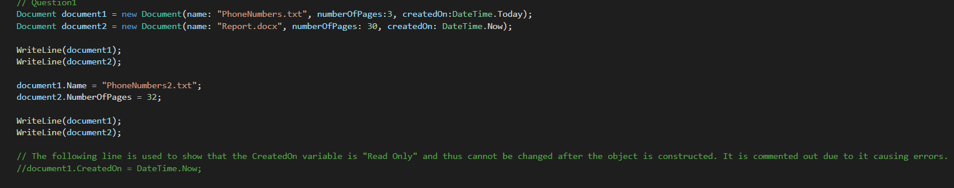

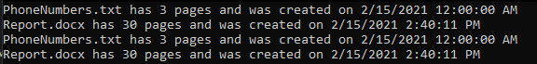

**2. Create a class Employee**

**a) *private* and *static field* nextAvailableID (int): create a *static constructor* to initialize this field to a random number (hint: you can use** [**System.Random class**](https://docs.microsoft.com/en-us/dotnet/api/system.random?view=netcore-3.1)**). You can assume that IDs are numbers between 1-9999. Since nextAvailableID is static, all the Employee objects will share this field.**

**b) with properties**

* **FirstName (string)**
* **LastName (string),**
* **ID (int): make it read only to allow initializing only with a constructor and then no more.**

**c) Add a constructor to allow setting properties FirstName and LastName. Hint: ID will be initialized to nextAvailableID (make sure to increment nextAvailableID by one)**

1. 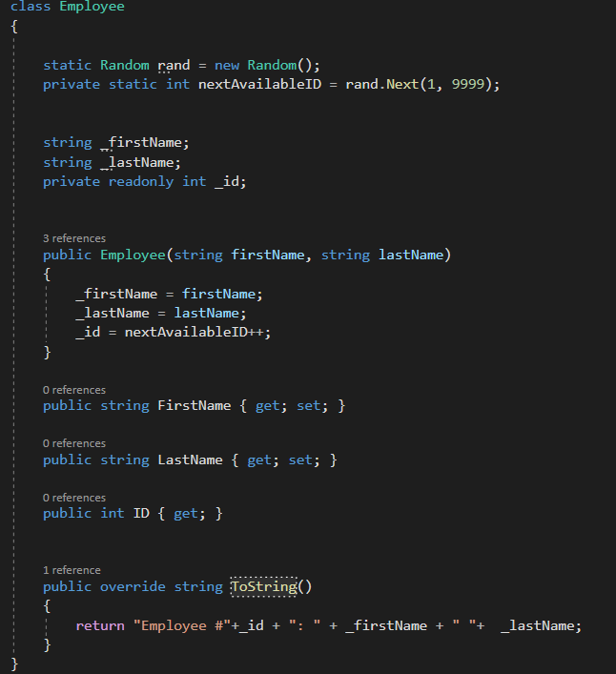**Add ToString Method to display the full name and ID of the employee**

**Then, write a Main method to test your class Employee.**

1. **Create four Employee objects with references e1, e2, and e3 by providing first and last name of each employee**
2. **Display the full name and id of each employee - note that each employee will have an automatically generated ID by the class Employee.**

